Becky Wass of Cornwall, England has come up with a good way for people to help their most vulnerable neighbors come through the COVID-19 epidemic. Older people and people with chronic health conditions who are being advised to self-isolate face many practical problems like how to get in groceries and fill their prescriptions. They also face the problem of debilitating loneliness. Becky believes that all neighborhoods are full of people who are willing to help. To release a wave of neighborly caring she has designed a postcard to help people get started.
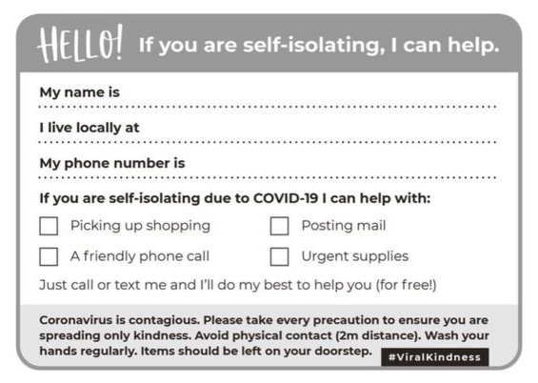

Becky said the idea came to her as she and her husband discussed ways to help. “Because fear has spread so quickly, it’s really important to try to spread kindness,” she told the BBC.

This simple, low-cost effort could be implemented quickly and with only modest trouble in the Greater Cincinnati/Northern Kentucky area – a region known for its generous and caring residents. Alerted to this opportunity by the media and supplied with postcards by their community councils or their churches/synagogues/mosques, an army of kindly people in the Cincinnati area could give critically needed help to their most vulnerable neighbors and alert authorities if they become aware that a neighbor with whom they’re in contact is declining dangerously. While doing these simple good deeds, they would be building strong social bonds in their communities for the future and filling their time creatively if temporarily furloughed from work or out of school.

Needed:
- Community foundations willing to underwrite the modest costs associated with the project (printing, stipends for ad hoc organizers/outreach workers)
- A coordinating agency to guide the effort until the epidemic passes

